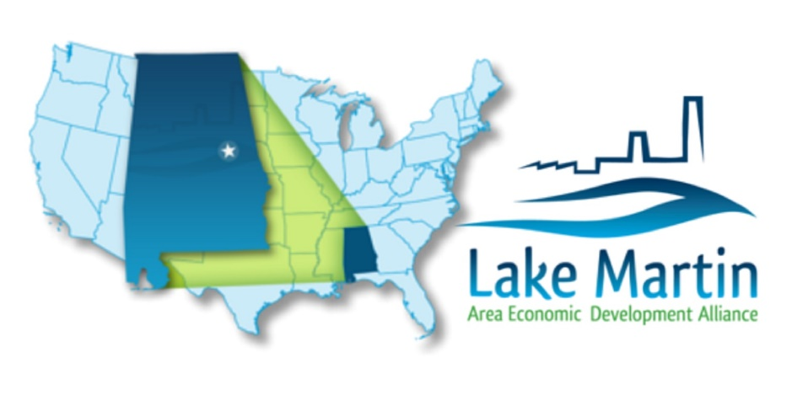

NEWS RELEASE

Lake Martin Area Economic Development Alliance
Contact: Denise Walls
Executive Director
(256) 750-5253
dwalls@lakemartineda.com

(Coosa County, AL April 11, 2024) The Lake Martin Area Economic Development Alliance Announces Two Rivers Lumber Plans $115 million Sawmill Project, Creating 130 jobs in the Lake Martin Area.
The Lake Martin Area Economic Development Alliance, Coosa County, and the City of Alexander City are proud to announce the location of Two Rivers Lumber Company, LLC (Two Rivers Lumber-Kellyton) to the Lake Martin Regional Industrial Park in Coosa County, Alabama. This will be Two Rivers’ second sawmill location in Alabama. Owners Roy Geiger, Jay McElroy, and Sean McElroy opened the first Two Rivers facility in Marengo County in 2017.

Two Rivers Lumber-Kellyton will employ 130 people at the Coosa County facility, with a capital investment of $115 million. Peak North America will be heading up construction of the mill, infusing additional revenue into the local economy over the anticipated 14-month construction phase. Two Rivers hopes to be in operation in the Lake Martin Regional Industrial Park by August 2025.

The average annual salary at the Two Rivers-Kellyton facility will be just over $51,000, and will include operators for the sawmill and planer mill sections of the facility, shipping/receiving, maintenance technicians, and heavy equipment operators, among others. There will be additional high skill management positions such as electrical and mechanical supervisors, safety managers, human resources, and accounting that will have annual salaries ranging from $65,000 to $110,000.

“The impact this project will have on the Lake Martin area is enormous and far reaching. The average projected wage is outstanding for our area and the number of skilled workers needed will hopefully mean that some of our residents with those skills that are currently driving out of town to work, will be able to go to work closer to home,” stated Denise Walls, Executive Director for the Lake Martin Area Economic Development Alliance. “That includes truck drivers and logging operators in the area who are currently driving out of their way to other mills to offload local timber.”

“We are excited about our decision to locate the new sawmill in Coosa County,” said Jay McElroy, co-owner of Two Rivers Lumber Company. “Denise and her local team have been extremely helpful throughout the process of finding the right site for us. No question has been too big or too small and she has gone out of her way to make sure that we were confident in our decision to locate here. We have felt welcome every step of the way.”

Local elected officials also expressed excitement over the project. Alexander City Mayor Woody Baird stated, “I would like to welcome Two Rivers Lumber to Alexander City as a community partner that I feel will have a great impact on the economy of our area. The cooperation between Lake Martin Area Economic Development, Alexander City and Coosa County brought us to this point. I think Two Rivers recognized that cooperation and the partnership we share was a deciding factor to them locating in our area.”
The Two Rivers facility will be in Coosa County Commissioner John Forbus’ District, and Commissioner Forbus echoed Mayor Baird’s thoughts. “It is an honor and great privilege to welcome Two Rivers Lumber to Kellyton. The Commission knows how hard everyone worked on this project and all the places that were considered as the new site for Two Rivers Lumber. We are very proud that the new Two Rivers Lumber sawmill will call Kellyton their home. The Lake Martin Regional Industrial Park has seen a lot of activity in the past year, and we are eager to have Two Rivers Lumber join in the excitement. Not only will they bring revenue to our county, but they will also employ 130 people when production starts in August 2025,” stated Forbus. “That is promising news for our community and county citizens who travel great lengths out of their towns for work and for those who are currently in local high schools and community colleges earning a trade degree. I look forward to meeting Jay and Roy and working alongside them for many years to come.”

About the Lake Martin Area Economic Development Alliance
The mission of the Lake Martin Area Economic Development Alliance is to attract new business and industry to the Lake Martin area and assist in existing business and industry expansion and retention. This mission is accomplished through a working relationship with state and local governmental entities and through development of attractive and functional industrial sites. www.lakemartineda.com

