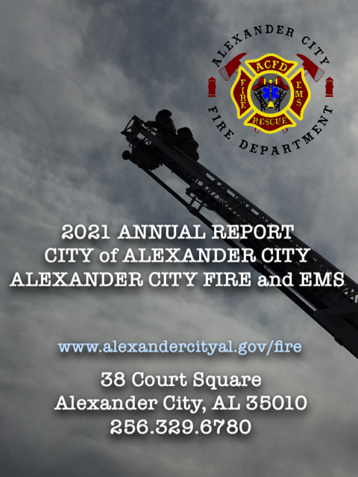

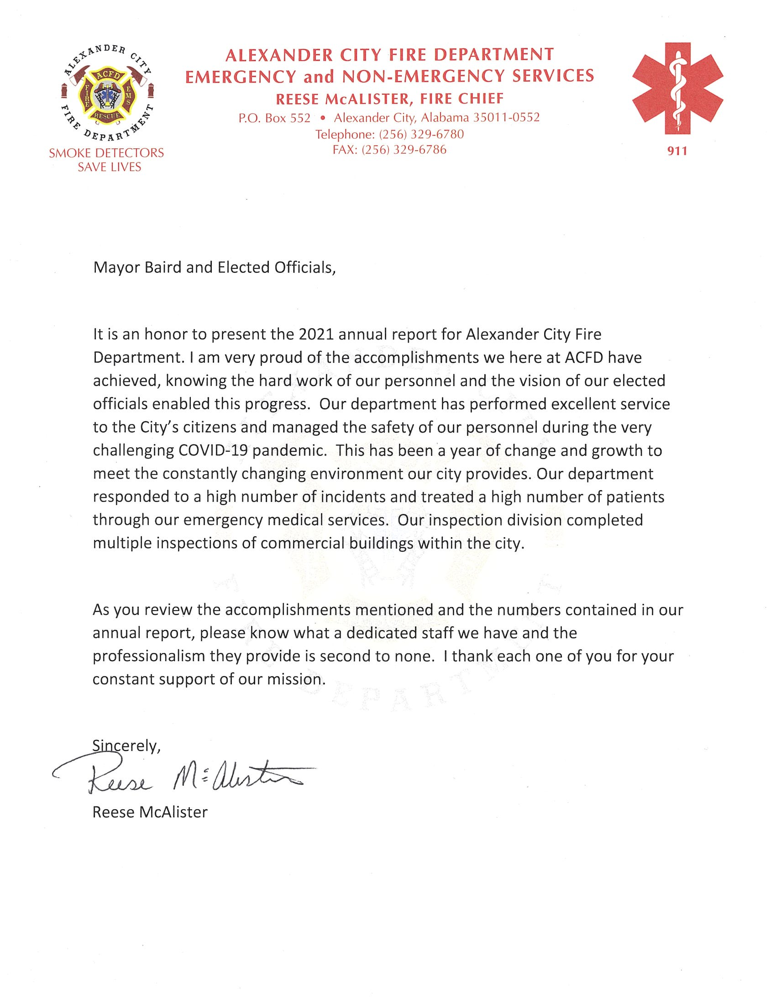

**EMS Totals for 2021:**  6525

MVC’s: 450

Transports: 4397

Non-Transports: 1444

COVID Contact: 229

Drownings: 5

**Fire Calls for 2021:**  408

Fire: 69

Hazard Condition: 13

Good Intent: 162

Severe Weather: 1

Other: 163

**Fire Inspections for 2021:** 153

**Blue E-911 Signs Installed for 2021:** 1042

**Smoke/Carbon Monoxide Detectors Installed for 2021:** 389

**CPR Classes Taught:** 115

**Hydrants Flushed:** 843

**Community Events:**

Santa on Fire Truck

City Trunk or Treat

911 Stair Climb Event

Children’s Hospital Burn Camp

Christmas on Main Street

October Fest

Breast Cancer Awareness Fundraiser

Tallapoosa LEPC Drill

Children’s Library Summer Reading Program

COVID-19 Vaccine Clinics

Tykes in Trucks

**ACFD Promotions:**

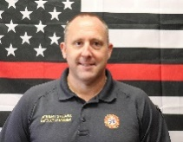***DEPUTY CHIEF FIRE MARSHAL***

Jeremy Spears Jonathan Florine 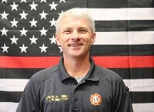

***CAPTAIN***

David Cantrell 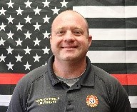 Jerry Sewell 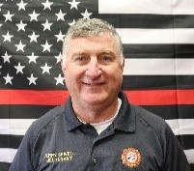

***LIEUTENANT***

Lance Meigs 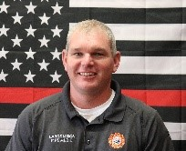 Zack Zipprich 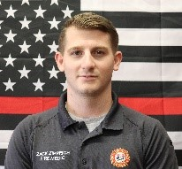

11-Firefighter/EMT Basics

8-Advanced EMT

2-Paramedics

Chief McAlister was elected as President of Southeast Alabama Fire Chief Association

Chief McAlister was elected to serve on Alabama Fire Chief’s Association

Captain Brewer was elected as Chair of East Alabama Regional Training Association

**Training:**

Hosted 1 Fire Recruit school

Total of 15 students

Hosted AFC Rope II

2 employees attended Fire recruit class at Auburn Fire

5 employees completed AFC Fire Instructor II course

5 employees completed AFC Live Fire Instructor Crossover

2 employees completed AFC Fire Inspector I

2 employees completed AFC Fire Instructor I

2 employees completed AFC Fire Officer I

8 employees completed AFC Emergency Vehicle Driver Course

1 Officer graduated from Alabama Public Safety Leadership Academy

4 Officers attended Alabama Fire Chief’s Association Winter Conference

3 Officers attended Alabama Fire Chief’s Association Summer Conference

Hosted 2 EMT Basic classes

Total 14 students

42 employees completed P.A.L.S.

42 employees completed A.C.L.S.

55 employees completed B.L.S.

**Total Training Hours for 2021:**

12,268 hours

**Firefighter of the Year:**

Will Windsor

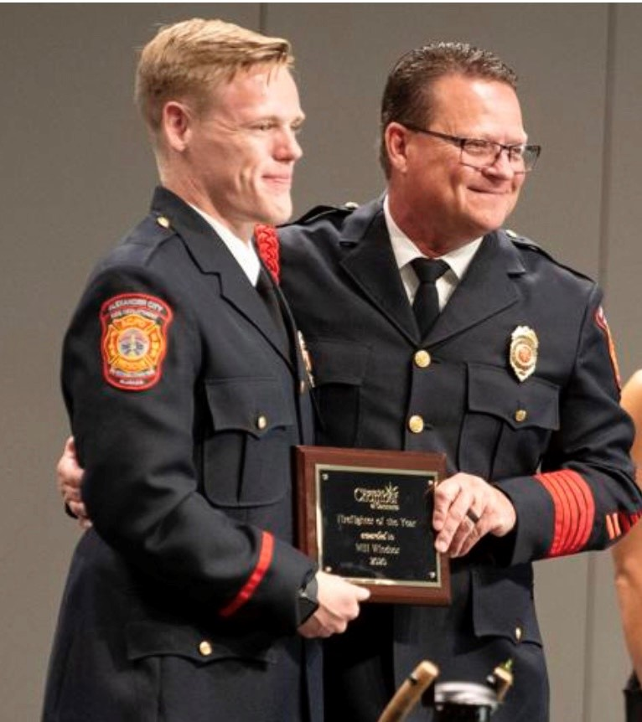

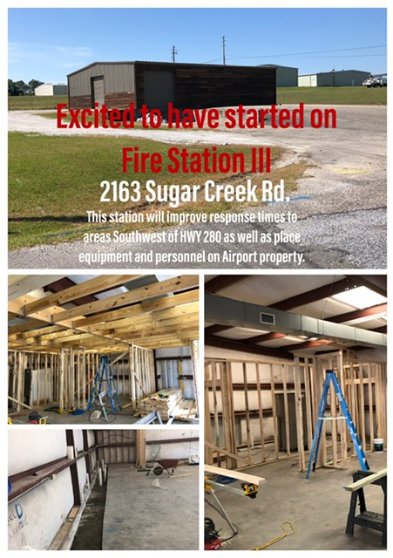

**Retirements of 2021:**

Deputy Chief Craig Clark

Deputy Chief Jamey Johnson

Captain David Macoy

Captain David Wayne Windsor

*A combined loss of 126 years of Service*

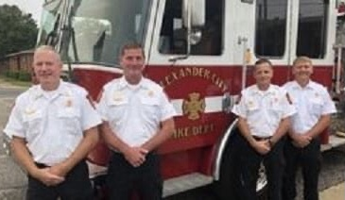

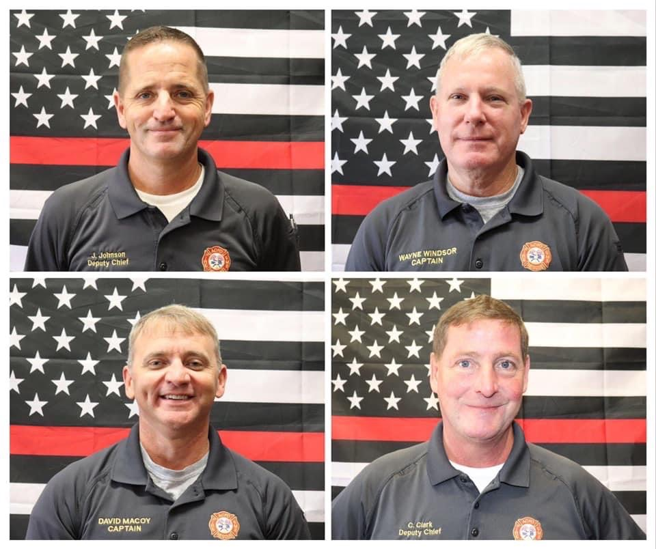

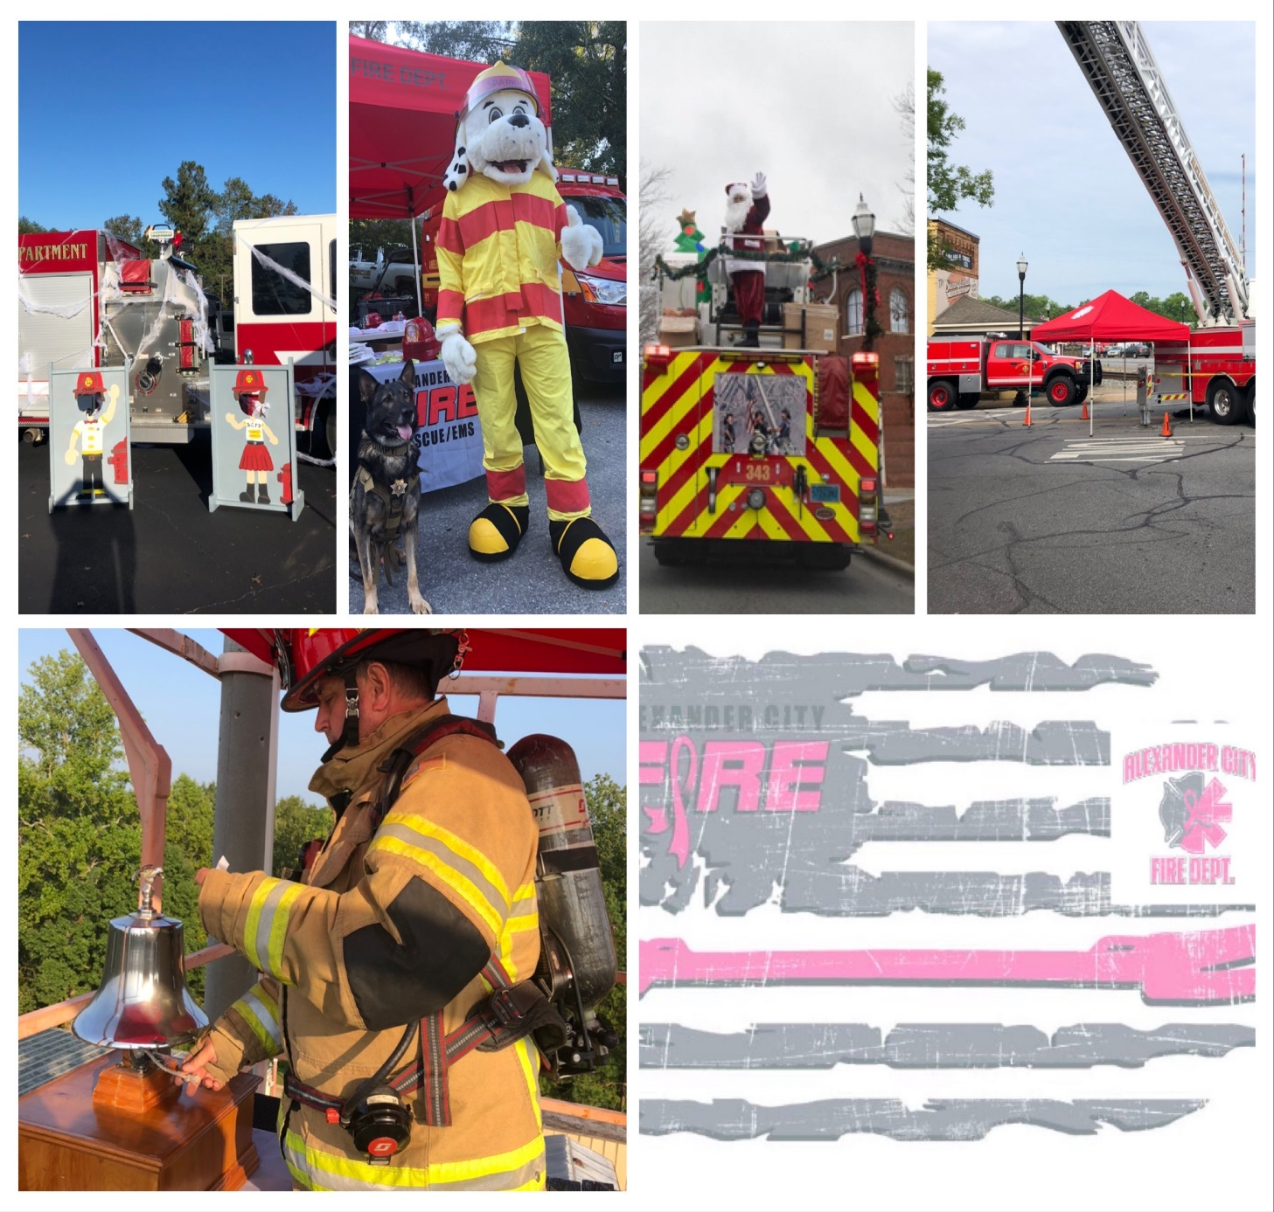

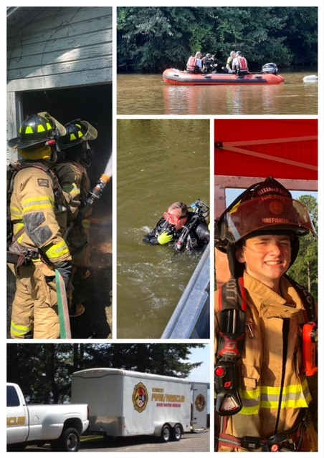

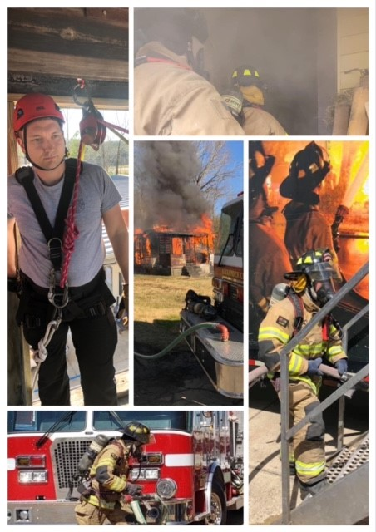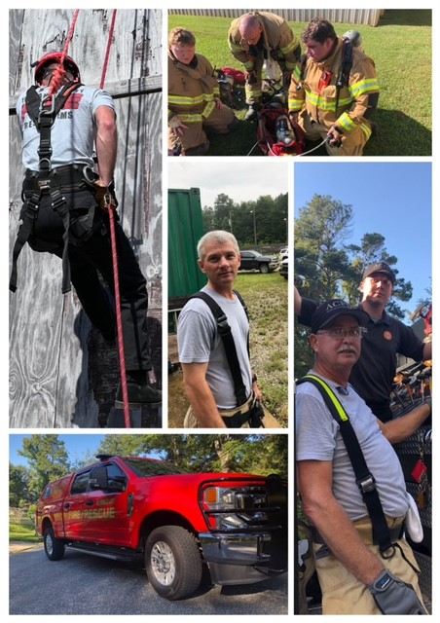

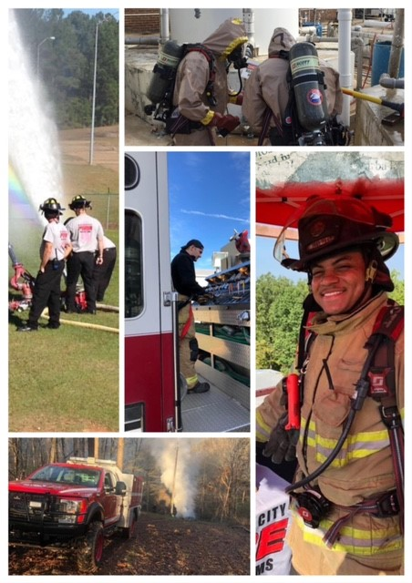

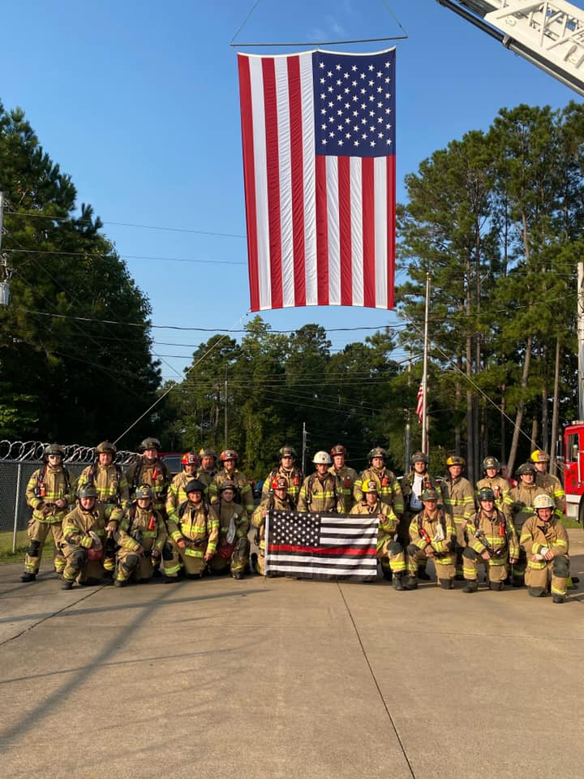

*“To provide the citizens and transients of Alexander City an effective, well-trained team of professionals to protect their lives and property through Fire Prevention and Education, Fire Suppression, Emergency Medcial Services, Rescue Services and Emergency Management”*

Your text here