281 James D. Nabors Drive
Council Chambers of Municipal Complex
Monday, March 4, 2024 --- Meeting at 5:30 p.m.

Regular Council Meeting Agenda
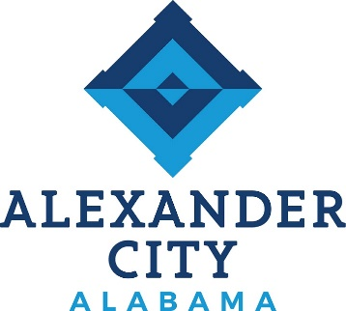

Call to Order: Council President Colvin

Opening Prayer: Pastor Tony Harris, Family Worship Center

Pledge of Allegiance: Councilor Eric Brown

Roll Call:

Approval of Minutes: February 19, 2024 Work Session
February 19, 2024 Regular Meeting

Approval of Agenda: March 4, 2024

Reports from Council on Standing Committees:
Finance Committee: Council President Colvin
Public Safety Committee: Councilor Eric Brown
Utilities Committee: Councilor Keel
Parks and Recreation: Councilor Chris Brown
Public Works Committee: Council President Pro Tempore Hardy
Buildings and Properties: Councilor Tapley

Reports from Special Committees:

Public Hearing: None

Report on Status of City Finances: None

Proclamation: None

Unfinished Business: None

New Business:

1. ORDINANCE: To Amend Alexander City Code § 62-1 – Fees for Use of Facilities. (Sponsored By: Councilor Chris Brown)

2. RESOLUTION: To Declare Personal Property as Surplus and no Longer Needed for Municipal Use. (Sponsored By: Councilor Tapley)

3. RESOLUTION: To Authorize the Mayor to Enter into Agreements with the Alabama Department of Transportation for the Relocation of our Utilities at the Bridge Replacement on State Route 63 over Sugar Creek. (Sponsored By: Council President Pro Tempore Hardy)

4. RESOLUTION: To Award Bid No 24-07 to Ferguson Waterworks for Paving Preparation Supplies at a cost not to Exceed $32,725.70. (Sponsored By: Council President Pro Tempore Hardy)

5. RESOLUTION: To Award Bid No. 24-08 to Chano & Sons, Inc. for Janitorial Services at Alex - Young Hollow at a Varied Cost Determined by Rental Space. (Sponsored By: Mayor Baird)

6. RESOLUTION: To Amend the FY21 CDBG Downtown Water Improvement Project at a Cost not to Exceed $338,244.84. (Sponsored By: Mayor Baird)

7. REQUEST: To Waive the $500.00 Application Fee for Michael Waldrop and Various Churches to Hold a Live Nativity at the Alexander City Sportplex in December, 2024.
8. REQUEST: To Waive the $500.00 Application Fee for James Gang Amusements, LLC to Hold a Carnival at the Alexander City Sportplex, April 3 – 6, 2024.

Public Comments (3 minutes per speaker):

Comments from the Mayor:

Comments from the Finance Director:

Comments from the City Clerk:

Comments from the Council:

Executive Session:

Adjournment:

The next Work Session & City Council meetings are scheduled for Monday,
March 18, 2024 at 4:30 and 5:30 p.m.

