281 James D. Nabors Drive
Council Chambers of Municipal Complex
Monday, November 6, 2023 --- Meeting at 5:30 p.m.

Regular Council Meeting Agenda
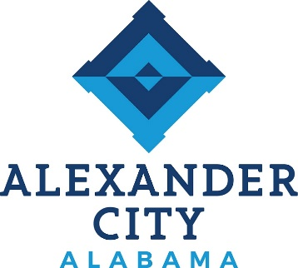

Call to Order: Council President Colvin

Opening Prayer: Council President Colvin

Pledge of Allegiance: Sassy Sisters

Roll Call:

Approval of Minutes: October 16, 2023, Work Session
October 16, 2023, Regular Meeting

Approval of Agenda: November 6, 2023

Reports from Council on Standing Committees:
Finance Committee: Council President Colvin
Public Safety Committee: Councilor Eric Brown
Utilities Committee: Councilor Keel
Parks and Recreation: Councilor Chris Brown
Public Works Committee: Council President Pro Tempore Hardy
Buildings and Properties: Councilor Tapley

Reports from Special Committees:

Public Hearing: None

Report on Status of City Finances: None

Proclamation: Alexander City Recycling Week

Unfinished Business:

New Business:

1. RESOLUTION: To Authorize the Mayor to Sign a Lease Contract for a Xerox Copy Machine for the Municipal Complex. (Sponsored By: Councilor Tapley)

2. ORDINANCE: To Regulate Land Disturbance Within the City of Alexander City, Alabama (Sponsored By: Council President Pro Tempore Hardy)

3. RESOLUTION: To Authorize the Mayor to Enter into an Agreement with the Alabama Department of Transportation to Authorize the Selection of an Engineering Consultant for the Relocation of Utilities at the Bridge Replacement on State Route 63 over Sugar Creek. (Sponsored By: Council President Pro Tempore Hardy)

4. RESOLUTION: To Adopt the Fiscal Year 2024 Capital Budget. (Sponsored By: Council President Colvin)

5. RESOLUTION: To Set a Public Hearing to Rezone Property Located at 3065 Highway 63 South from RR (Reserve Residential) to B2 (General Business). (Sponsored By: Mayor Baird)
6. ORDINANCE: To Establish the Annual Salary of the Mayor for the 2025 Quadrennium. (Sponsored By: Council President Colvin)
7. ORDINANCE: To Establish the Annual Salary of the Councilmembers for the 2025 Quadrennium. (Sponsored By: Council President Colvin)
8. RESOLUTION: To Award Bid No. 24-01 to Southern Recycling for Demolition of the Former City Hall and Police Department Buildings in an Amount not to Exceed $175,000.00. (Sponsored By: Mayor Baird)

9. RESOLUTION: To Award Bid No. 23-19 to Avery Landscaping & Associates, LLC, for Sidewalk Improvements, Project No. TAPUC-TA22(909) at a Cost not to Exceed $120,623.00. (Sponsored By: Councilor Tapley)

10. RESOLUTION: To Amend the City of Alexander City, Alabama Personnel Manual, §11.4.2.2. Health Plan and §11.9, Summary of City Provided Benefits. (Sponsored By: Council President Pro Tempore Hardy)
11. RESOLUTION: To Authorize the Lake Martin Industrial Development Board to Enter into a Tax Abatement Agreement with Hyundai Motor Manufacturing Alabama, LLC (Sponsored By: Council President Colvin)

Public Comments (3 minutes per speaker):

Comments from the Mayor:

Comments from the Finance Director:

Comments from the City Clerk:

Comments from the Council:

Executive Session:

Adjournment:

The next Work Session & City Council meetings are scheduled for
Monday, November 20, 2023 at 4:30 and 5:30 p.m.

