281 James D. Nabors Drive
Council Chambers of Municipal Complex
Tuesday, June 20, 2023 --- Meeting at 5:30 p.m.

Regular Council Meeting Agenda
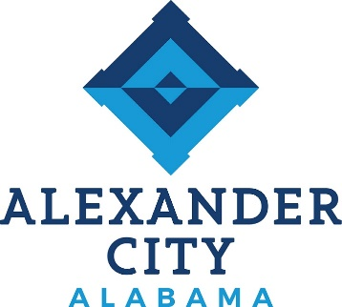

Call to Order:

Opening Prayer: Held in Work Session

Pledge of Allegiance: Held in Work Session

Roll Call:

Approval of Minutes: June 5, 2023 Regular Meeting

Approval of Agenda: June 20, 2023

Reports from Council on Standing Committees:
Finance Committee: Council President Colvin
Public Safety Committee: Councilor Eric Brown
Utilities Committee: Councilor Keel
Parks and Recreation: Councilor Chris Brown
Public Works Committee: Council President Pro Tempore Hardy
Buildings and Properties: Councilor Tapley

Reports from Special Committees:

Public Hearing: None

Report on Status of City Finances: Romy Stamps, Finance Director

Proclamation: None

Unfinished Business:

1. RESOLUTION: To Authorize the Mayor to Enter into an Agreement with the
Alabama Department of Corrections to Allow the use of Inmates at the City of
Alexander City, Alabama (Sponsored By: Council President Pro Tempore Hardy)
HELD FROM JUNE 5, 2023
New Business:

1. RESOLUTION: To Authorize the Mayor to Sign a Non-Residential Lakeshore Permit Agreement with Alabama Power Company (Sponsored By: Councilor Keel)

2. ORDINANCE: To Amend Alexander City Code Article II – City Council, § 2-25, Order of Business and § 2-27, Agenda. (Sponsored By: Council President Colvin)

3. ORDINANCE: To Prohibit Depositing Certain Substances upon Public Roadways and Streets. (Sponsored By: Council President Pro Tempore Hardy)
4. ORDINANCE: To Rescind Article II – Recreation Advisory Board and Article V, Division 2. Beautification Board. (Sponsored By: Councilor Chris Brown)

5. RESOLUTION: To Authorize the Mayor to Submit an Application to the Alabama Department of Economic and Community Affairs to Request Appalachian Regional Commission Funds in the Amount of $500,000.00
For Water System Improvements. (Sponsored By: Councilor Keel)

The next City Council meeting is scheduled for Monday, July 10, 2023 at 5:30 p.m.

