281 James D. Nabors Drive
Council Chambers of Municipal Complex
Monday, December 12, 2022 --- Meeting at 5:30 p.m.

Public Notice Regular Council Meetings
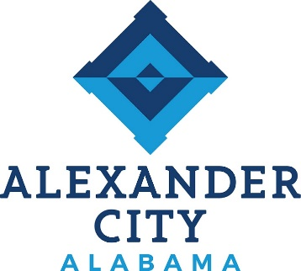

RESCHEDULED COUNCIL MEETINGS

The Regular and Work Session Council Meetings scheduled for Monday, December 5, 2022, have been rescheduled for Monday, December 12, 2022, at 5:30 p.m.

If anyone has any questions or concerns, please contact the City Clerk at (256) 329-6700.

